|  | FPT ACADEMY INTERNATIONAL  FPT – APTECH COMPUTER EDUCATION |
| --- | --- |

Centre Name: ACE-HCMC-2-FPT.

Address: 590 Cach Mang Thang 8, District 3, Ho Chi Minh City, Viet Nam.

**[First Fashion]**

| Supervisor: | Phạm Thị Lánh | |
| --- | --- | --- |
| Term: | T1.2202.M0 | |
| Batch No: | 2 | |
| Group No: | 2 | |
| Order: | Full name | Roll No. |
| 1. | Nguyễn Quang Long | Student1368175 |
| 2. | Trần Chấn Đông | Student1368176 |
| 3. | Trần Trung Huy | Student1368158 |
| 4. | La Tấn Tài |  |

Month 06 Year 2022

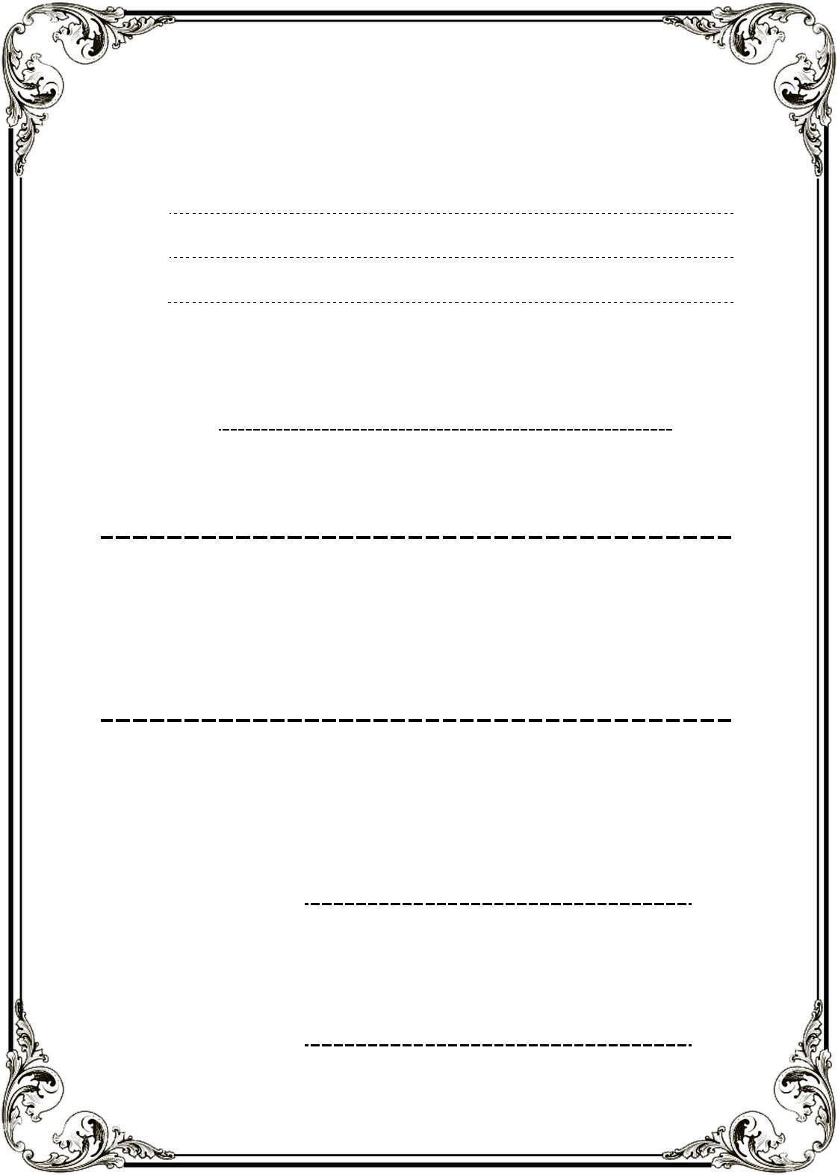This is to certify that

**Mr. NGUYỄN QUANG LONG**

**Mr. TRẦN CHẤN ĐÔNG**

**Mr. TRẦN TRUNG HUY**

**Mr. LA TẤN TÀI**

Have successfully Designed & Developed

**FIRST – FASHION**

Submitted by: **Ms. PHAM THI LANH**

Date Of Issue: June, 2022

Authorized Signature:

# Acknowledge

As we understand that the eProject is a step-by-step learning environment that closely simulates the classroom and Lab based learning environment into actual implementation. It is a project implementation at your fingertips!! An electronic, live juncture on the machine that allows you to.

✓ Practice step by step i.e., laddered approach.

✓ Build a larger, more robust application.

✓ Usage of certain utilities in applications designed by the user.

✓ Single program to unified code leading to a complete application.

✓ Learn implementation of concepts in a phased manner.

✓ Enhance skills and add value.

✓ Work on real life projects.

✓ Give a real-life scenario and help to create something more complicated and useful.

✓ Mentoring through email support.

We would like to send a great thanks to our professor and other students for the adorable support during the time in the project.

Beside several mistakes we had made in the project, we hope to have more opportunities to widen our knowledge in the web developing world.

We also thank you so much for your information and the “demo” project from India APTECH to help us get more reality experience in this project. Since we have gained more experience from this project, we will not stop learning anything as much as we can to be more successful in the future.

Your Sincerely,

Team Group 02.

# Synopsis

- The Objective of this program we aim is to give a sample project to work on real life projects. These applications help us build a larger, more robust application.

- The objective is not to teach us HTML/JavaScript but to provide us with a real life scenario and help us create basic applications using the tools.

- Hence, we can revise the chapters before we start with the project.

- This project The Objective of this program is to give a sample project to work on real life projects. These applications help you build a larger, more robust application.

- The objective is not to teach you the software but to provide you with a real-life scenario and help you create basic applications using the tools.

- You can revise the topics before you start with the project.

- This project is meant for students who have completed the module of HTML5.

- These programs should be done in the Lab sessions with assistance of the faculty if required.

- The website (in this project) is a tool that help the company to access the

international market and gain more and more new customers.

- It is very essential that a student has a clear understanding of the subject.

# 

# REVIEW 1

## Problem Definition

STELLAR has a store for Shoes. They have a collection of shoes. Now with the changing environment, they want their presence on the Internet. Hence they need to have a website with all their products listed on the website. Consumers should find it easy to view various products and decide upon purchasing the right product to meet their requirements.

A website needs to be designed to display various shoes available with the store. Details of locations using GeoLocation API (eg. GoogleMaps), feedback must be included.

The website is to be developed for the Windows Platform using HTML5, JavaScript and Geolocation. The site should work well in all leading browsers including Chrome, IE, Firefox etc.

Here are some problems need to be resolved:

1. With the changing environment, more and more customers are interested in shopping online and this issue leads to the situation that customers want to find information about various products easily on the STELLAR website and purchase the right product that meets their needs.

2. Online customers have an interest in reading reviews before purchasing specific products.

3. Existing customers needing some help and support on the product after purchase would have to contact the STELLAR office through phone number or email address. Moreover, many customers want to come to the store to view the product and then decide whether to buy it or not.

## Customer Requirements Specifications

| WEBMASTER: |
| --- |
| Input:  ● Control website database, input product information,… |
| Process:  ● Analyze website |
| Output:  ● Website interface, images, forms, …  ● Giving interaction |

| HARDWARE / SOFTWARE REQUIREMENT: |
| --- |
| Software:  ● Notepad/HTML editor  ● Dreamweaver/Javascript |
| Hardware:  ● A minimum computer system that will help you access all the tools in the courses is a Pentium 166 or better  ● 64 Megabytes of RAM or better |

## Architecture and Design of the project

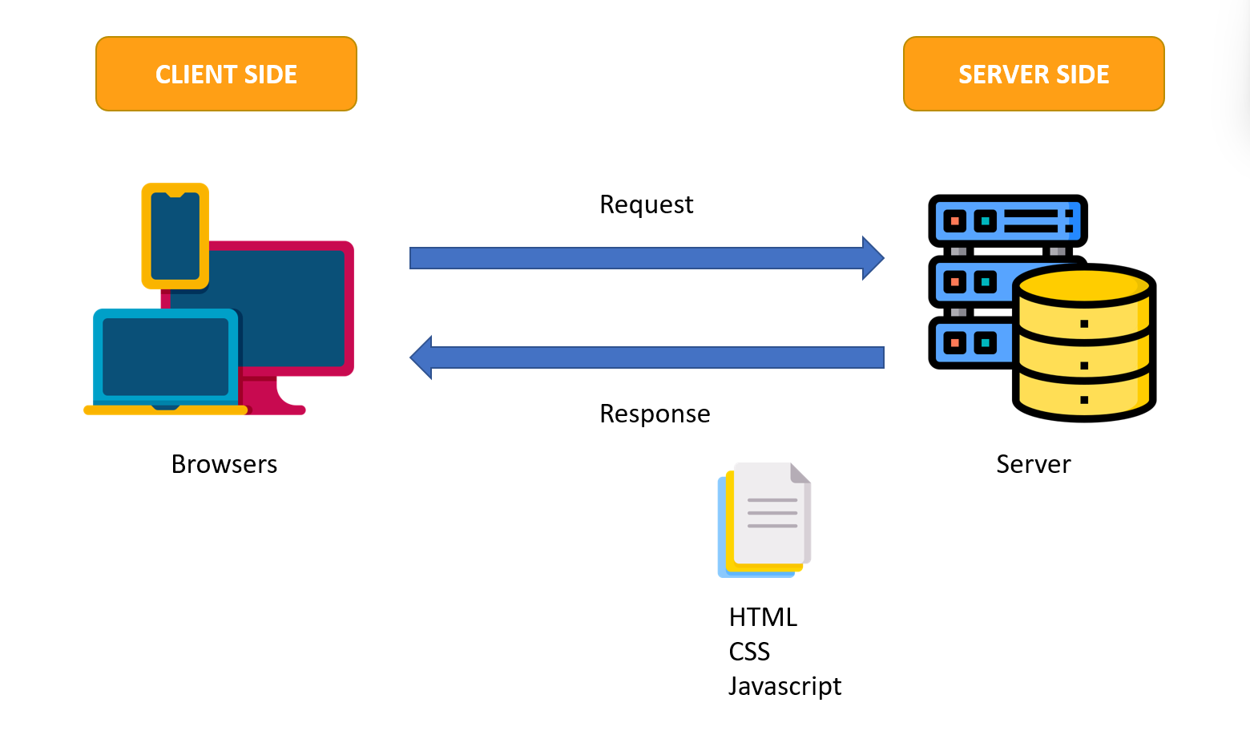

## Site map

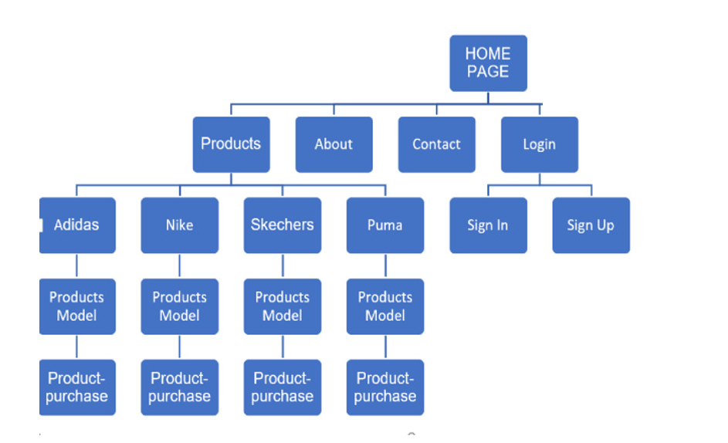

**REVIEW 1**

## Screen shots

### Homepage

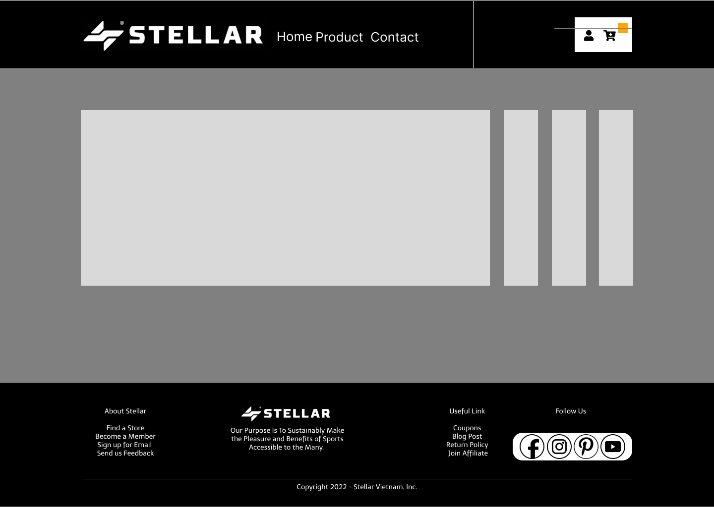

**Description:** This is a homepage of STELLAR, the top of this page is a header, after that is a navigation bar. The main part of a homepage beside the slider also includes . The footer of a homepage has 4 sections: first will help visitors find our store’s location and link to sign up to become a member. Second is our brand slogan. Next is the link for coupons and the last one is the link for our social pages.

### Sign in

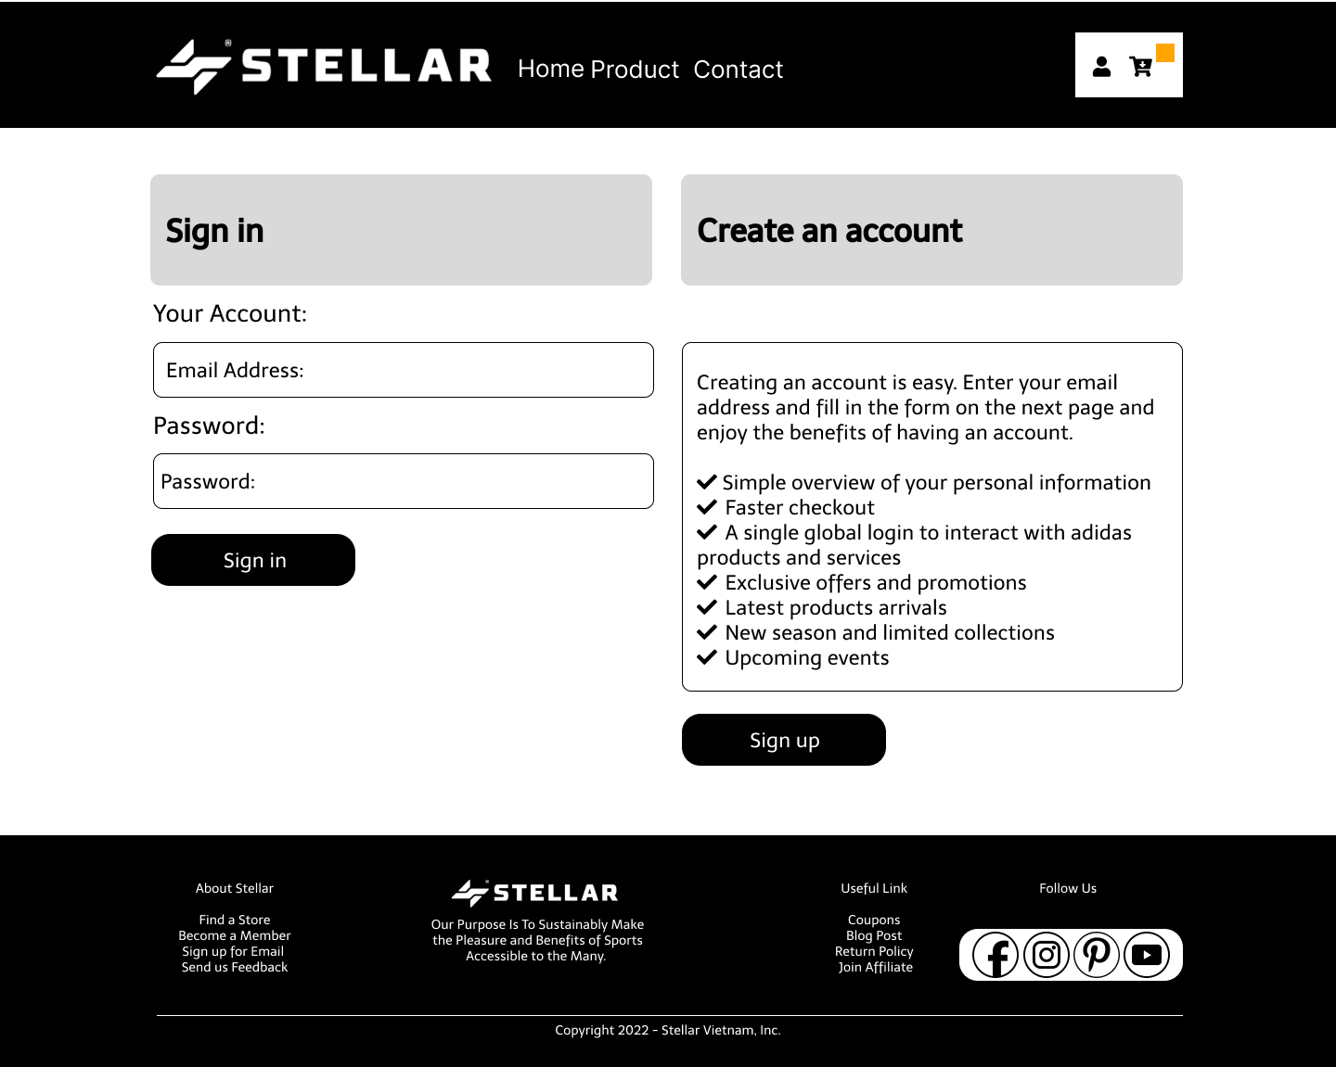

**Description:** When the user clicks on the human icon in the header, it leads to a sign in page. This form requires the user to enter an email address and a password. The user can also click on the check box: “Keep log-in” for the auto sign in next time. After clicking the login button, the user will be redirected to the homepage.

If the user does not have an account to sign in, they can click the button “sign up” to create their own new account.

### Sign up

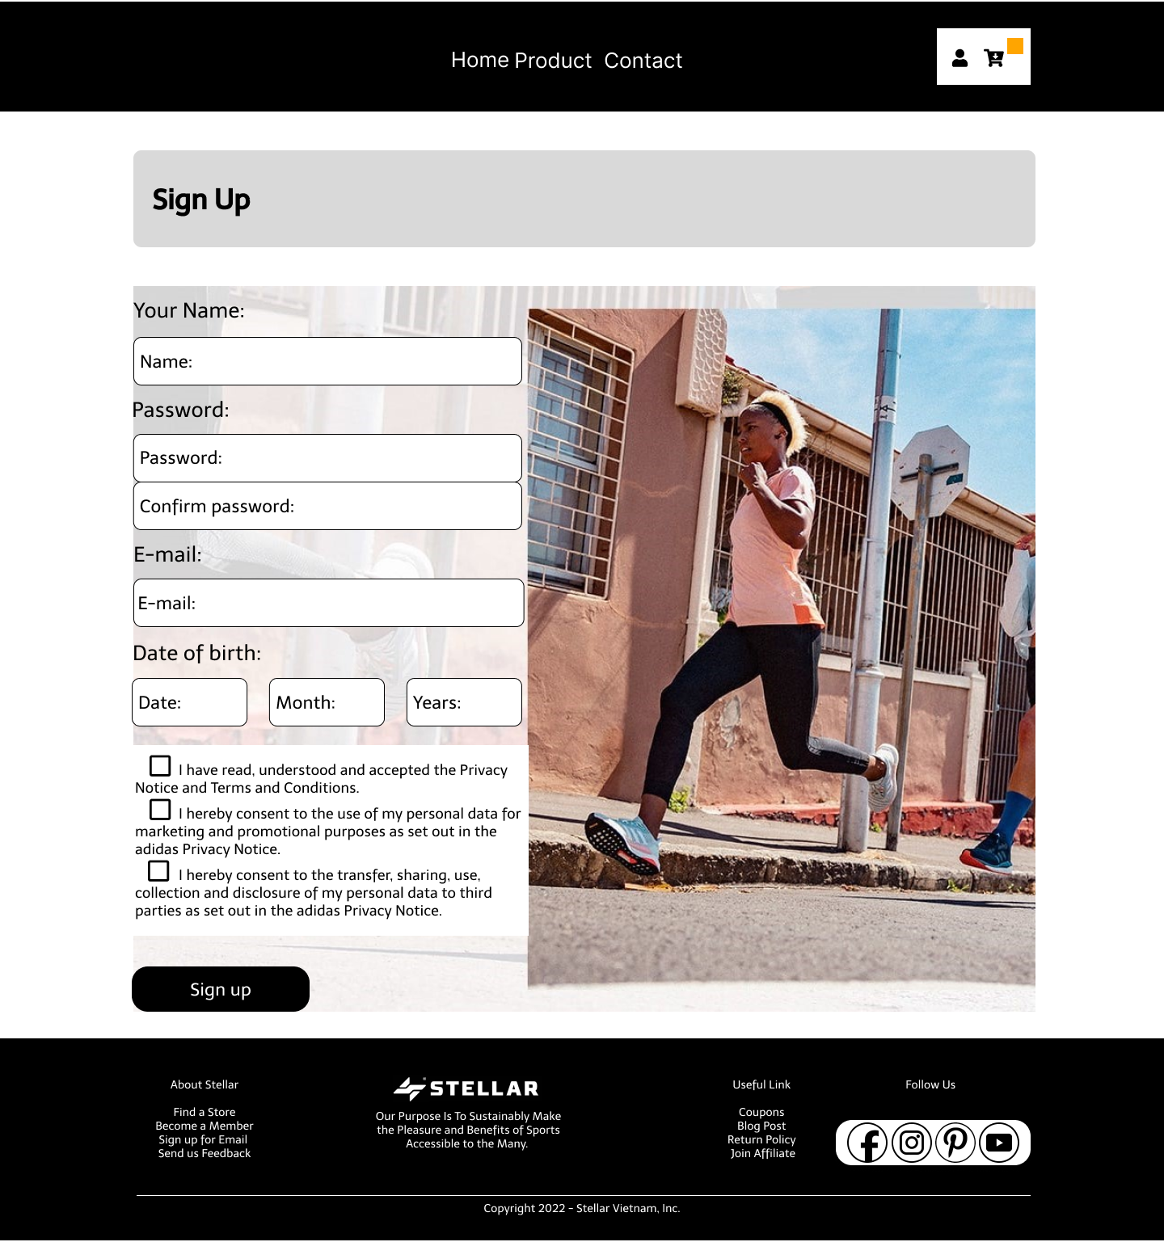

**Description:** This sign up form requires the user to enter 6 fields: Name, email ,password, confirm password, address and phone number. After that, the user has to click on all the checkboxes to agree on our store policy. And finally, click the “sign up” button to create a new account and redirect to the home page.

### Product:

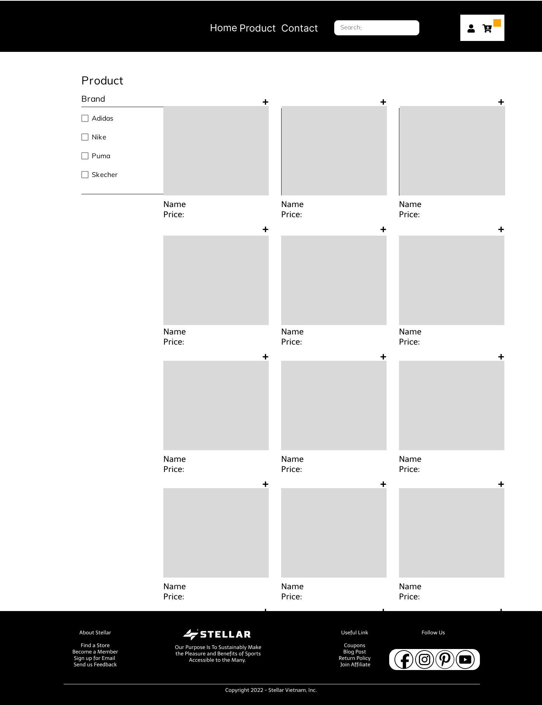

**Description:** When the user clicks on the “Product” tag in navigation of the home page, it will lead to this page. The main part of this page contains 2 sections: filter and sale items.

The filter part will help the user to find out the brand and price of the product that they want conveniently.

The icon search on the navigation can help the user to find the name of the product that they want.

### Product Comparison

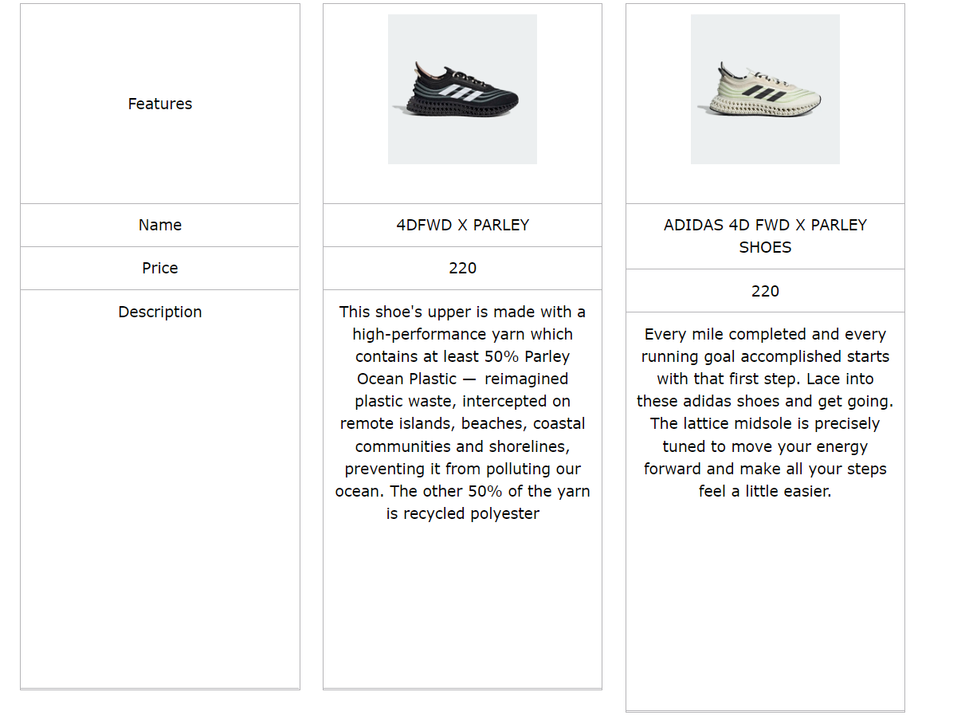

**Description:** When the user clicks on the add icon on a specific product, this product will be added to comparison, at least 2 items and less than 4 items can be compared. When the user clicks on compare button, a compare modal will appear, it shows detail information of those items

### Product Detail

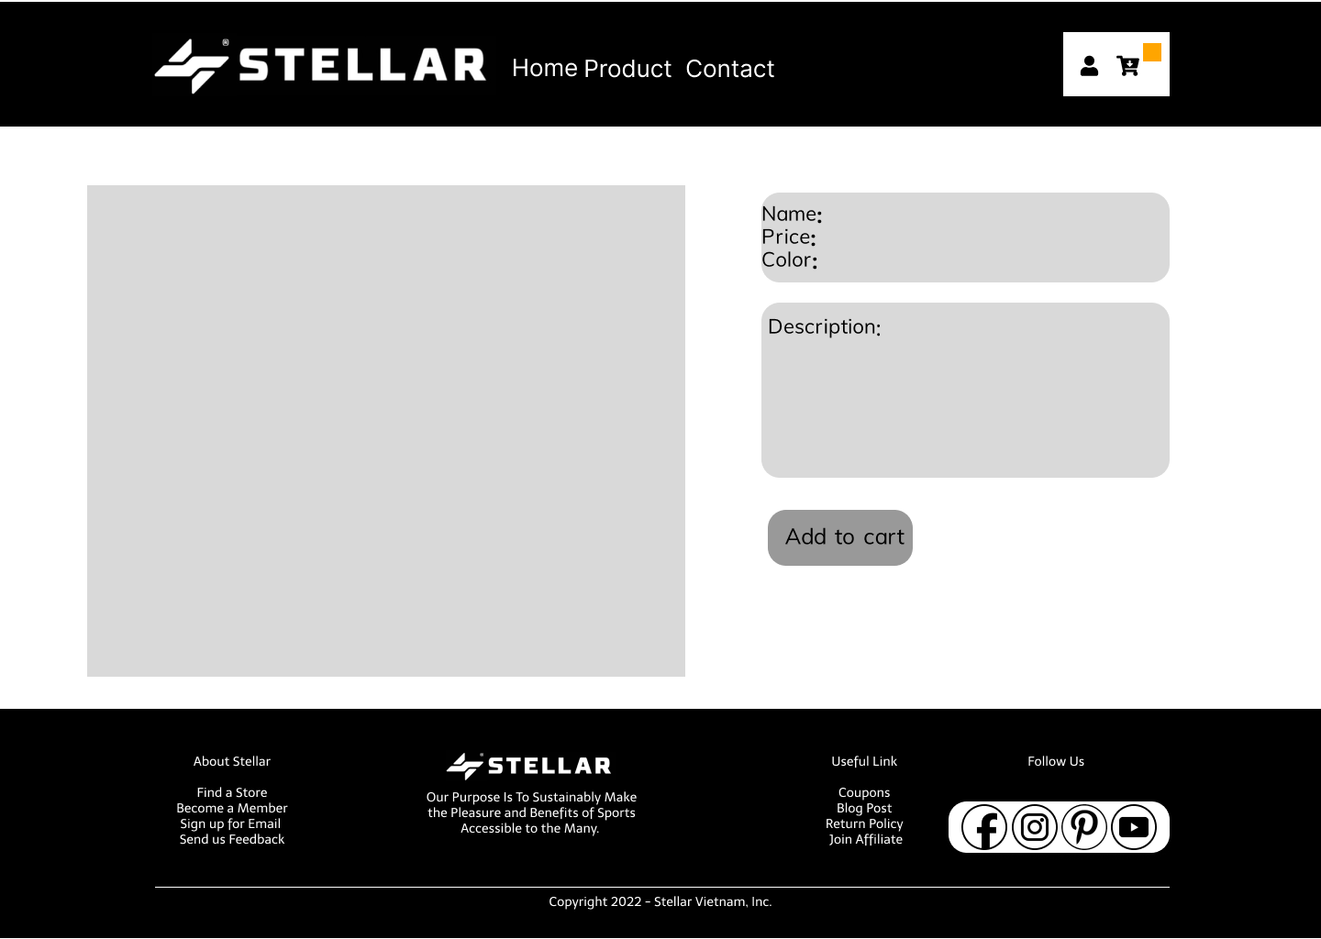

**Description:** When the user clicks on a specific product it will lead to this product detail page. Beside in detail information about the product, it also contains Call to Action buttons Add to cart.

### Cart Page:

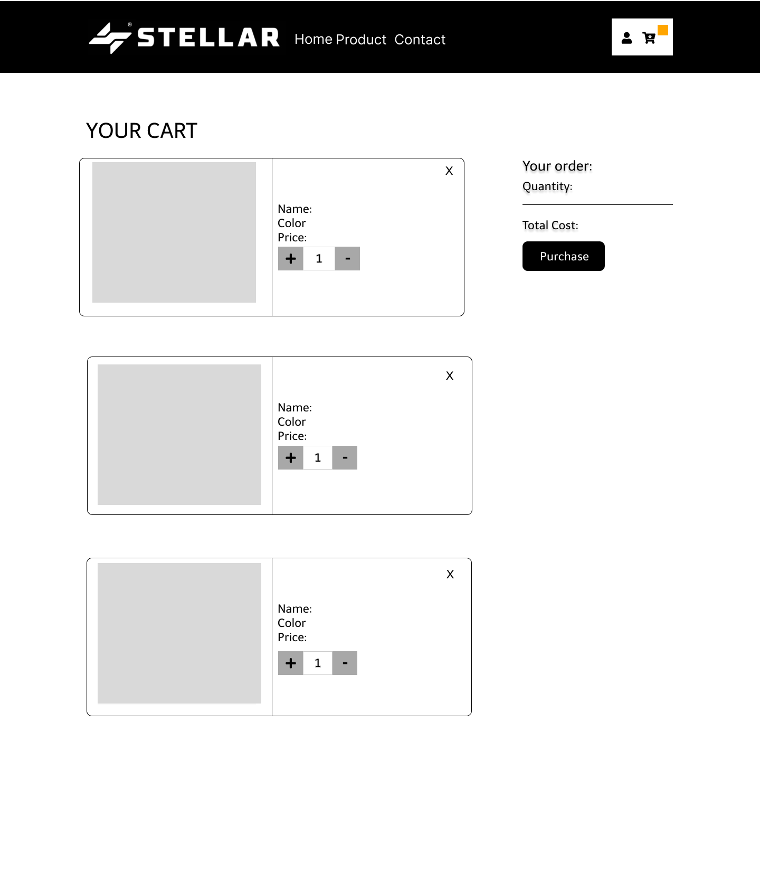

**Description:** When the user clicks on the cart icon in the header, the cart information will appear. It includes products that users have already added to cart, the user can select all items or remove items which they don’t have the intention to buy.

### Check out

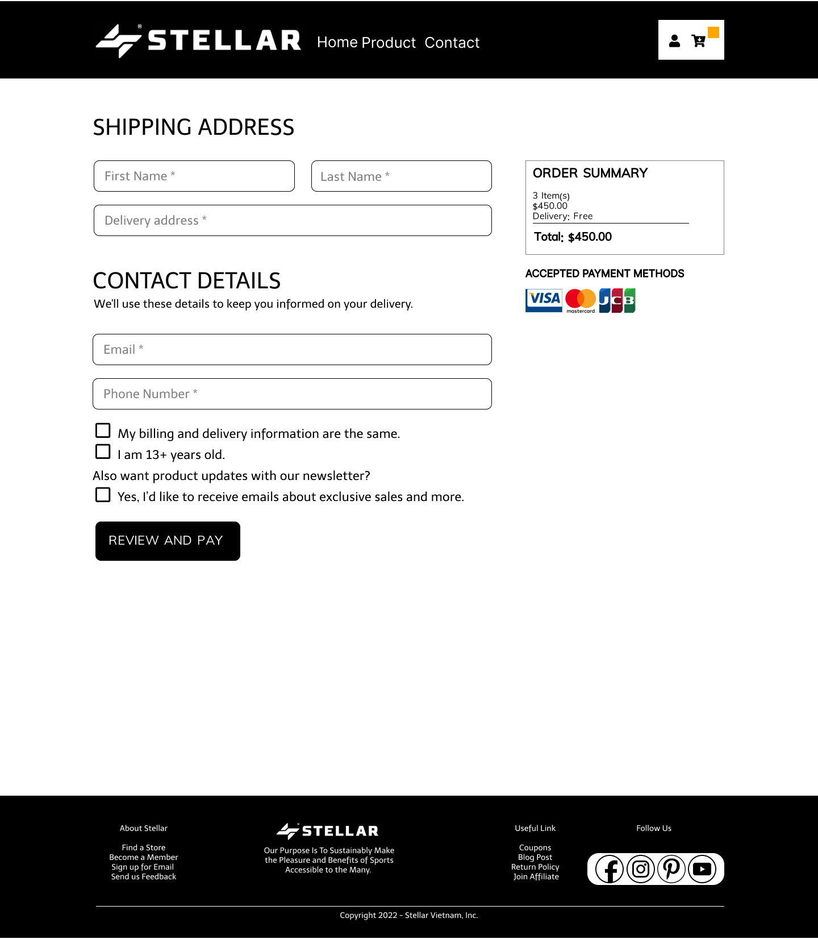

**Description:** After clicking the Check out button on the Cart or Purchase button in Product Detail Page, the user will be redirected to this checkout page. The left part of this page contains a form which requires the user to enter and the other side is the Order summary.

### Contact

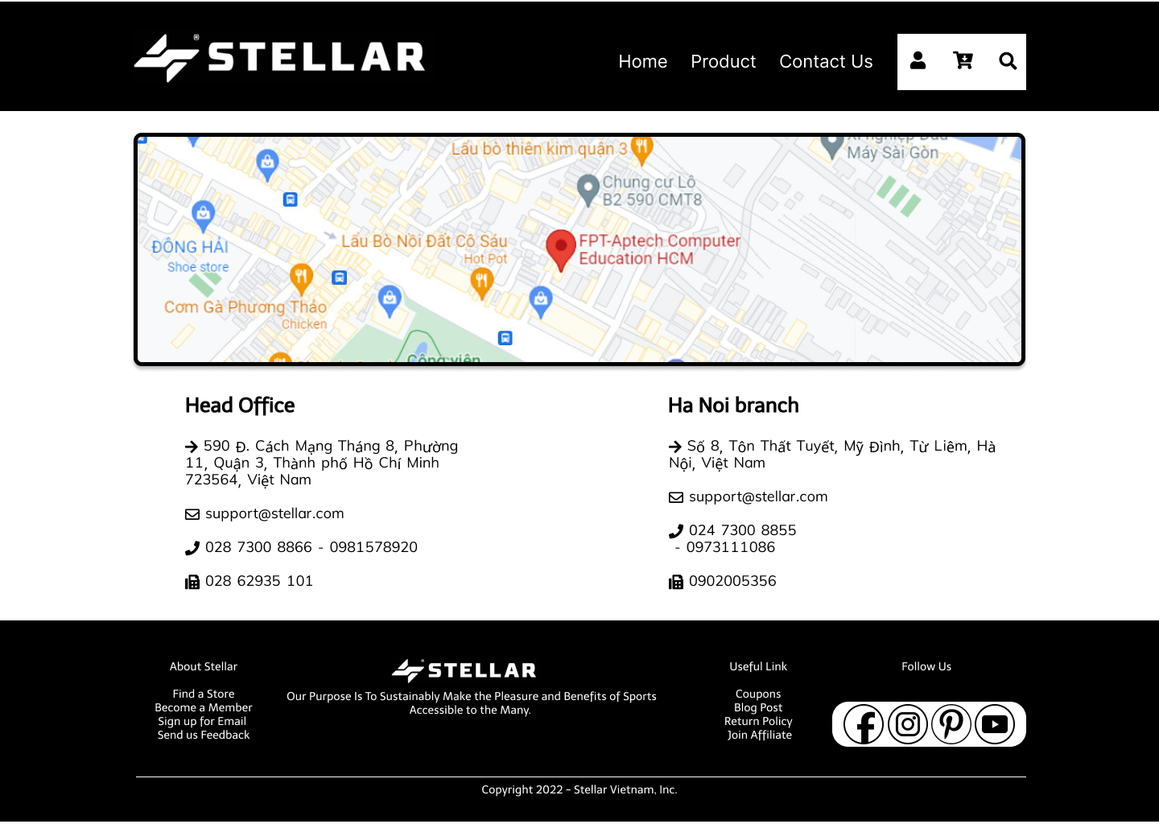

**Description:** After clicking the Contact Us tag on the navigation bar, the user will be redirected to this page. The first part of this page is a map, beside it is a detailed location of STELLAR'S Branches. The last part of this page is a Send information form to send their information to STELLAR.

## Task Sheet

| **Project Ref No.** | **Project Title – Ask Me Mobile** | **Activity Plan Prepared by** | **Date of preparation of Activity Plan** | | | |
| --- | --- | --- | --- | --- | --- | --- |
| **Task** | **Actual Start Date** | **Actual Days** | **Teammate Names** | **Status** |
| Brainstorming ideas for layouts and Project Object | | Long, Đông,  Huy | 18/05/2022 | 1 days | Long, Đông | Completed |
| Draw sitemaps and architecture design | | Đông, Long,  Huy | 23/05/2022 | 3 days | Long, Đông,  Huy | Completed |
| Wireframing general page layout | | Long | 23/05/2022 | 2 days | Long | Completed |
| Collect static assets (pictures, mp4, documentation,…) | | Huy, Đông | 18/05/2022 | 3 days | Huy, Đông | Completed |

# REVIEW 2

### Homepage

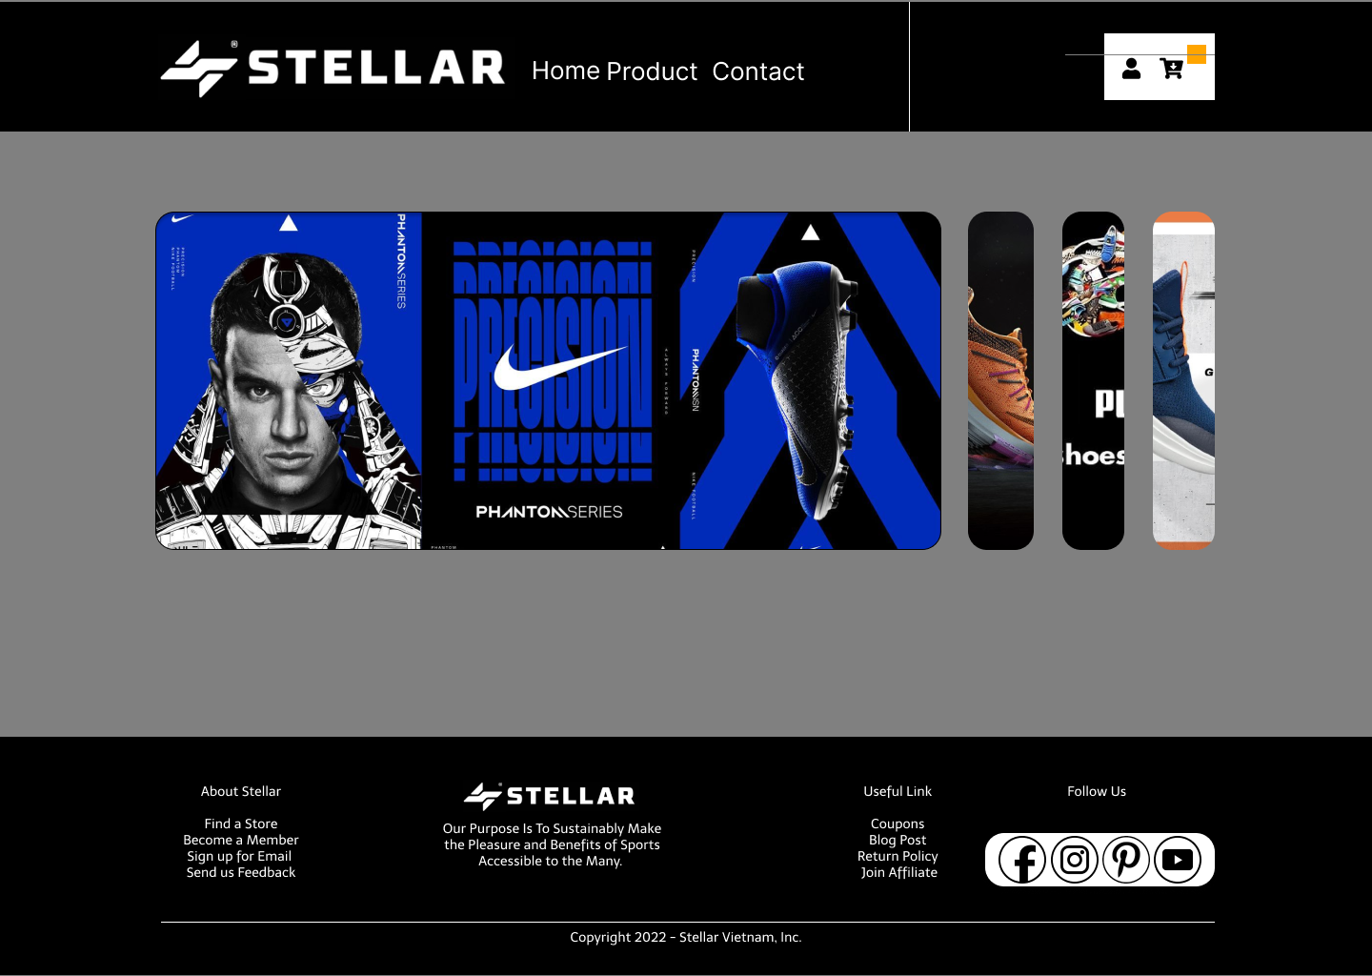

### Sign In:



### Sign Up:



### Product Page:

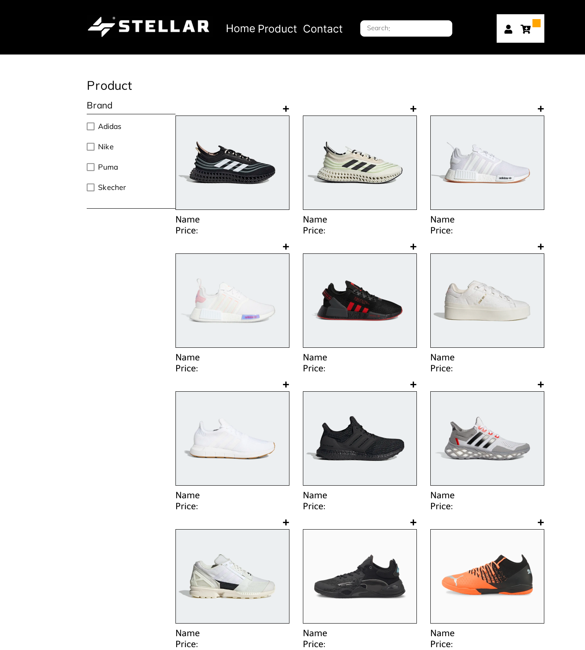

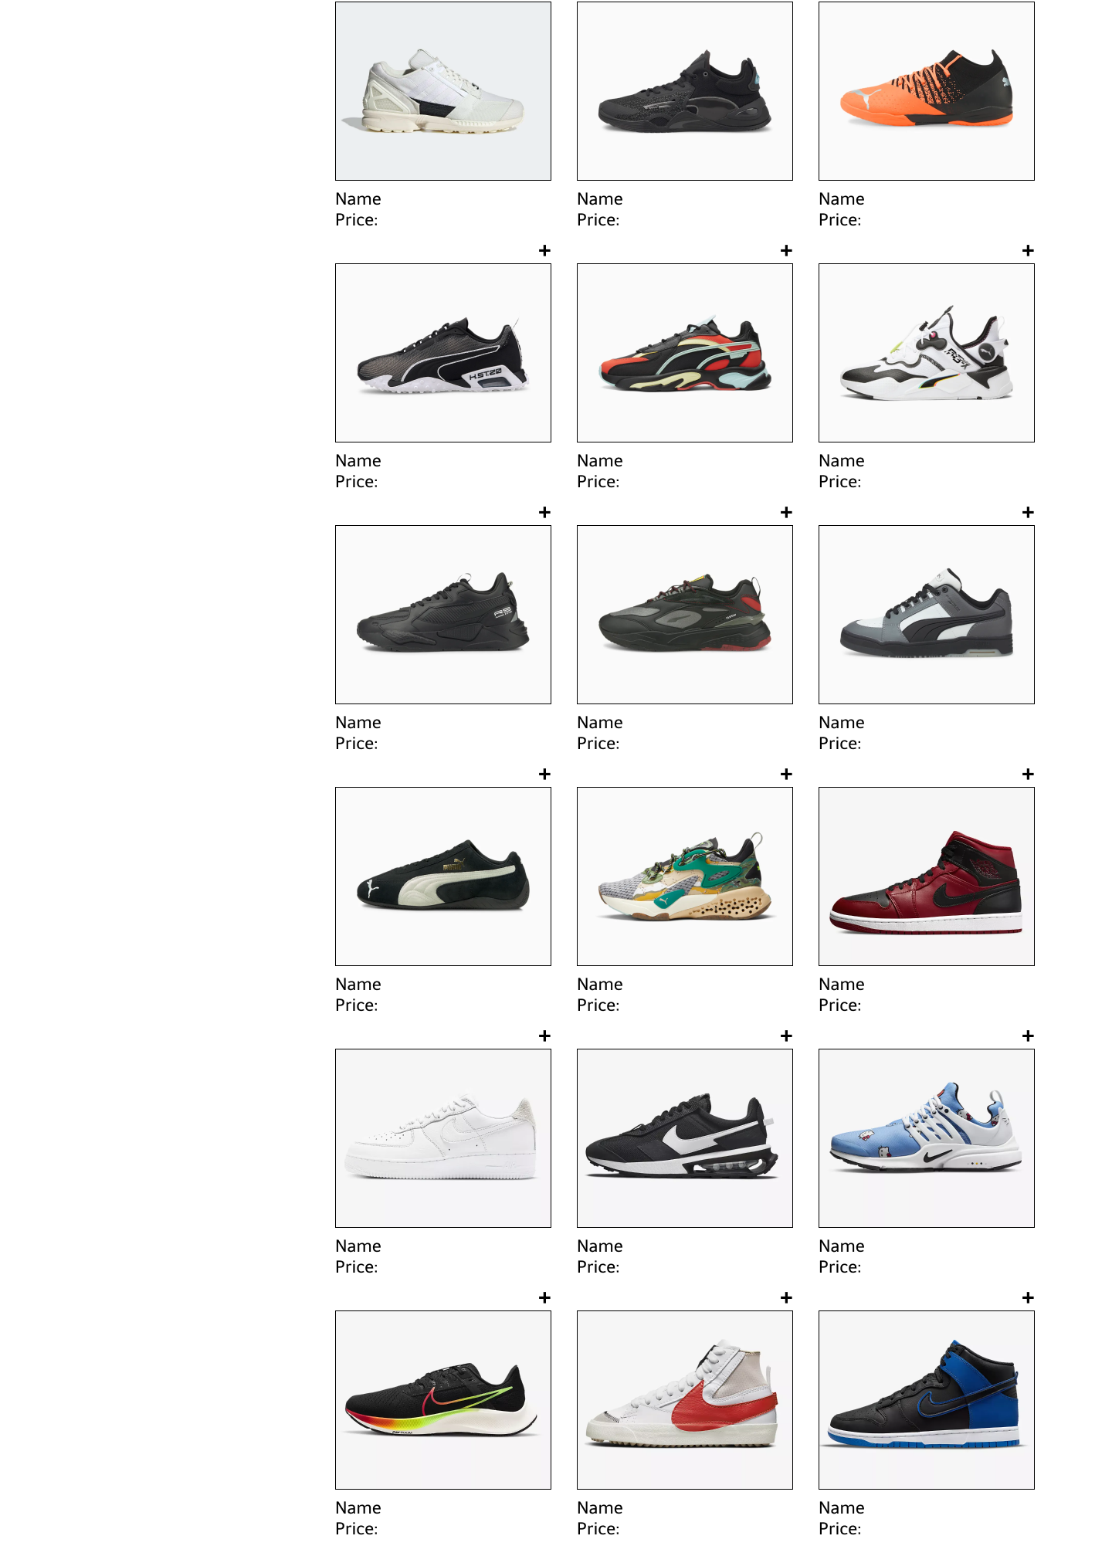

### Compare Product:

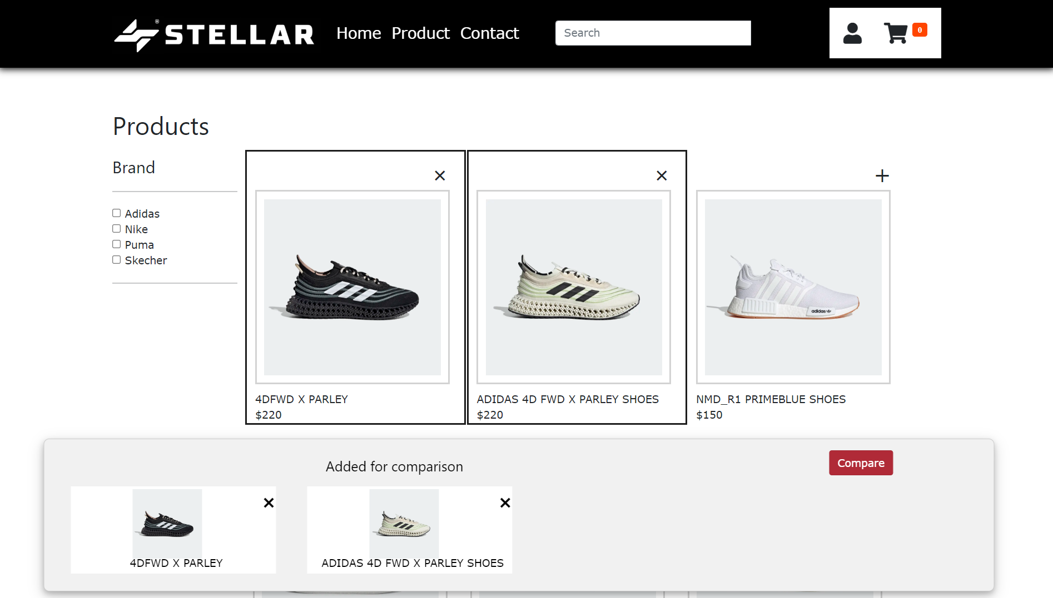

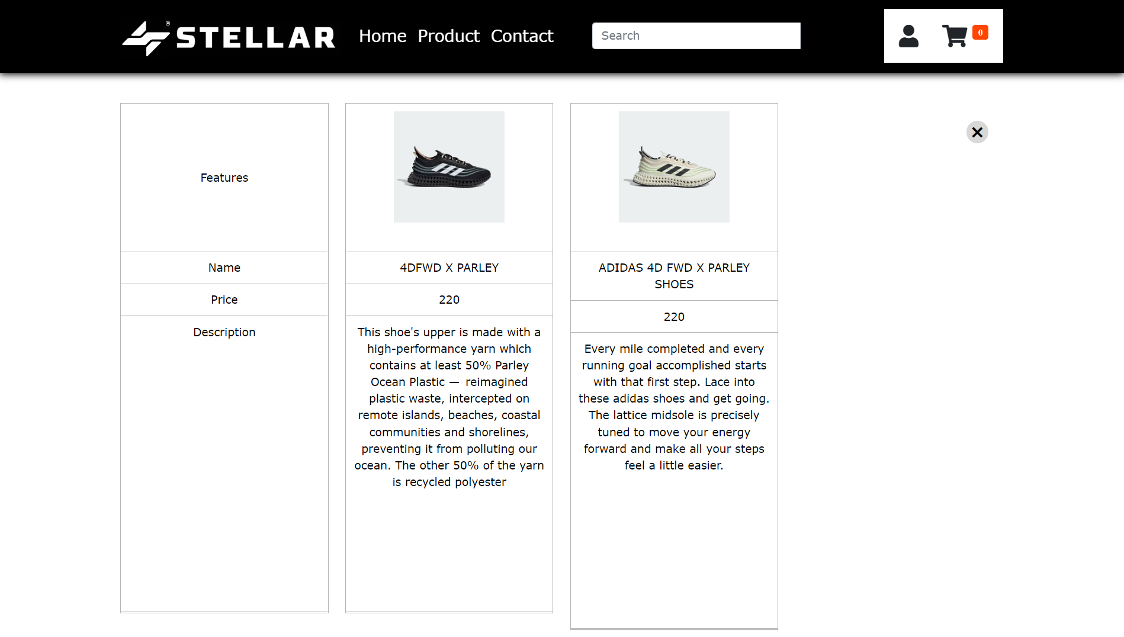

### Product Detail:

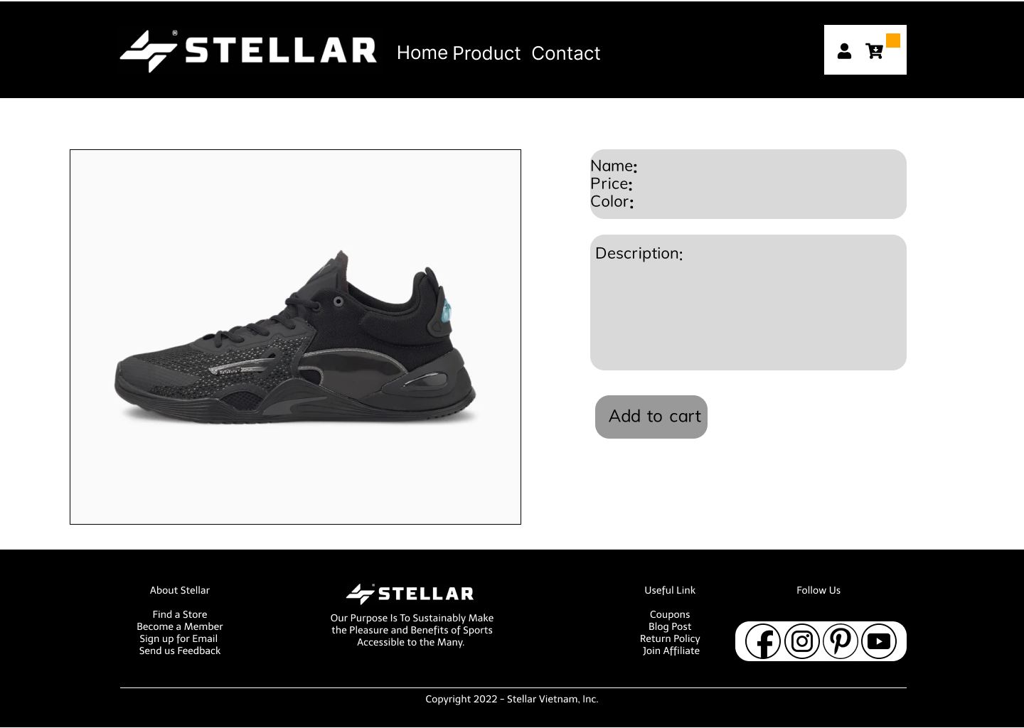

### Cart Page:

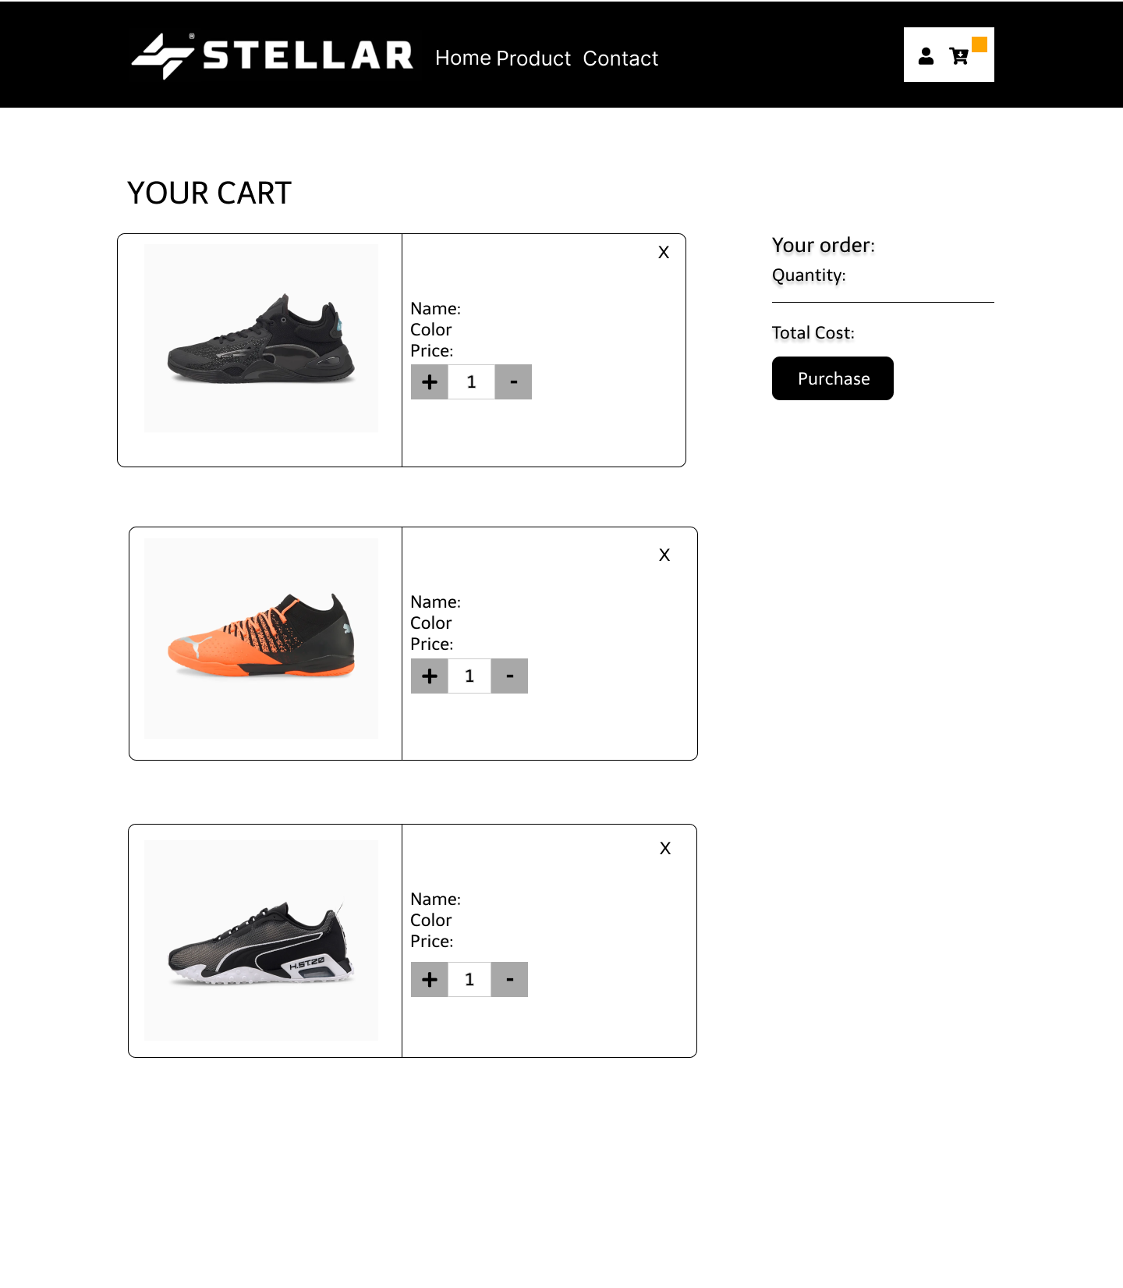

### Check Out Page:



### Contact Page:

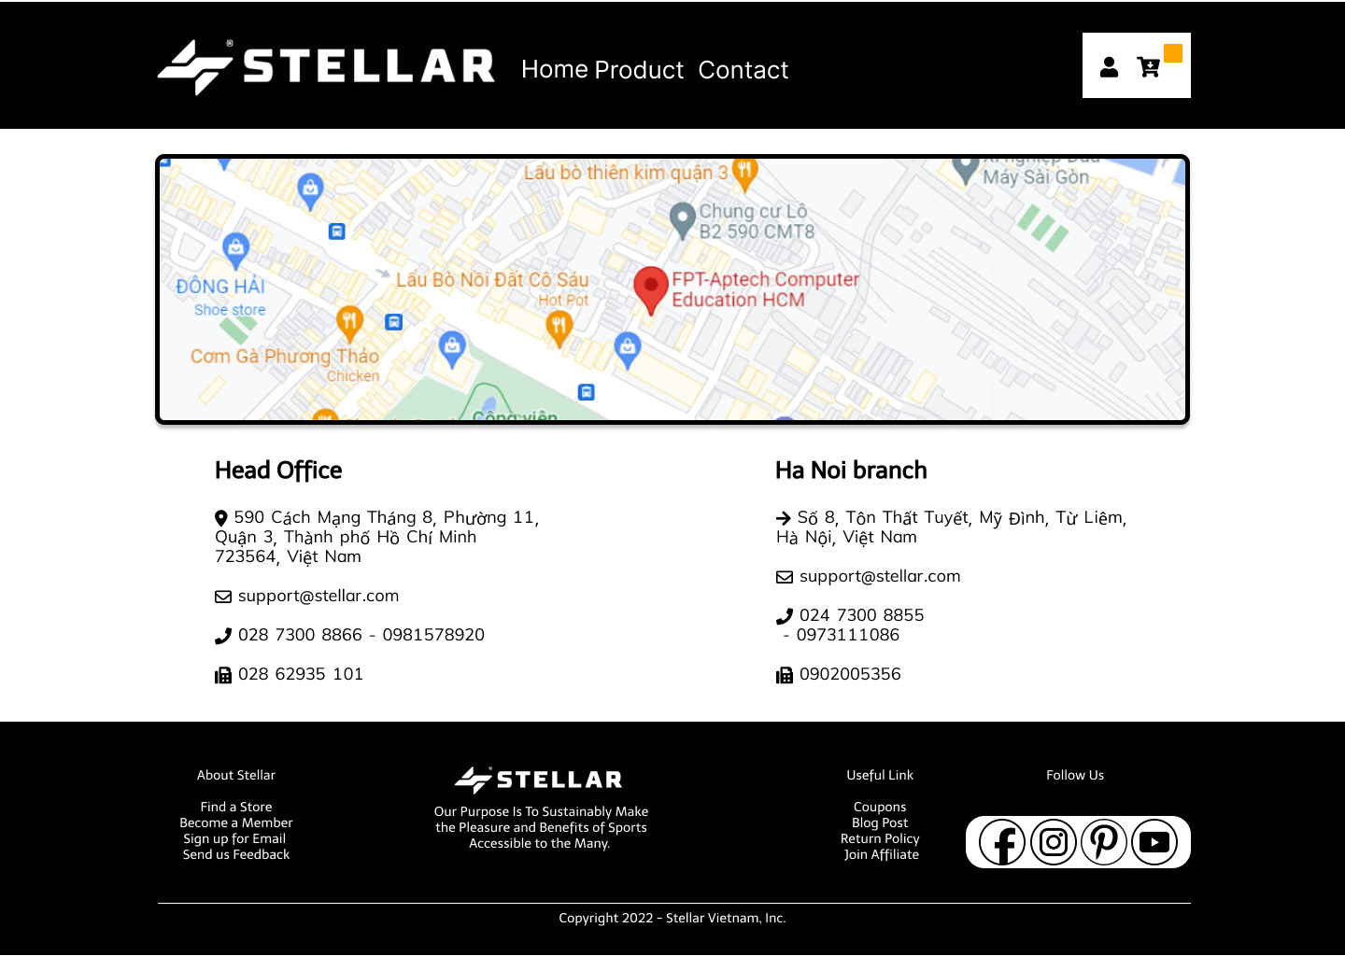

## Task Sheet

| **Project Ref No.** | **Project Title – Ask Me Mobile** | **Activity Plan Prepared by** | **Date of preparation of Activity Plan** | | | |
| --- | --- | --- | --- | --- | --- | --- |
| **Task** | **Actual Start Date** | **Actual Days** | **Teammate Names** | **Status** |
| Brainstorming ideas for layouts and Project Object | | Long, Đông, Huy | 18/05/2022 | 1 days | Long, Đông, Huy | Completed |
| Draw sitemaps and architecture design | | Long, Đông,  Huy | 23/05/2022 | 2 days | Long, Đông, Huy | Completed |
| Wireframing general page layout | | Long | 23/05/2022 | 2 days | Long | Completed |
| Collect static assets (pictures, mp4, documentation,…) | | Đông, Huy, Tài | 18/05/2022 | 3 days | Đông, Huy, Tài | Completed |
| Design & Build Homepage | | Đông | 25/05/2022 | 8 days | Đông | Completed |
| Design & Build Sign in | | Đông  Huy | 30/05/2022 | 2 days | Đông  Huy | Completed |
| Design & Build Sign up | | Đông  Huy | 30/05/2022 | 2 days | Đông  Huy | Completed |
| Design & Build Sales | | Long, Đông | 30/05/2022 | 3 days | Long, Đông | Completed |
| Design & Build Product Category/Search Page | | Long, Đông | 11/06/2022 | 5 days | Long, Đông | Completed |
| Design & Build Product Detail | | Long, Đông | 31/05/2022 | 4 days | Long, Đông | Completed |
| Design & Build Cart Dropdown | | Long, Đông | 31/05/2022 | 10 days | Long, Đông | Completed |
| Design & Build Check out | | Long, Đông | 30/05/2022 | 2 days | Long, Đông | Completed |
| Design & Build Contact | | Đông | 30/05/2022 | 1 days | Long, Đông | Completed |
| Product Comparison | | Long, Đông | 11/06/2022 | 5 days | Long, Đông | Completed |
| Write Project Report | | Long | 16/06/2022 | 1 days | Long | Completed |

## Testing document

| **Sr.No** | **Features Tested** | | | **Remarks** |
| --- | --- | --- | --- | --- |
| 1 | Are all the users able to view the images and links? | | | OK |
| 2 | Is the GUI content devoid of spelling mistakes? | | | OK |
| 3 | Is the application user-friendly? | | | OK |
| 4 | Is the Website launching correctly in all popular | |  | OK |
| browsers? |  |  |
| 5 | Are all the forms validated with proper criteria? | | | OK |
| 6 | Do all text links lead to the appropriate website? | | | OK |
| 7 | Do all image links lead to the appropriate website? | | | OK |
| 8 | Are all the images and links clearly visible on the page? | | | OK |
| 9 | Does the Web page work properly in all the tested | |  | OK |
| browsers? |  |  |
| 10 | Does the Web page take too long to be loaded fully? | | | OK |
| 11 | Is the navigation sequences correct through all the Web | | | OK |
| pages on the site? | |  |
| 12 | Is the JavaScript code working as expected in all click | | | OK |

## Final checklist

| **Sr.No** | **Features Tested** | | | **Remarks** |
| --- | --- | --- | --- | --- |
| 1 | Are all the users able to view the images and links? | | | OK |
| 2 | Are the GUI content devoid of spelling mistakes? | | | OK |
| 3 | Is the application user-friendly? | | | OK |
| 4 | Is the Website launching correctly in all popular | |  | OK |
| browsers? |  |  |
| 5 | Are all the forms validated with proper criteria? | | | OK |
| 6 | Do all text links lead to the appropriate website? | | | OK |
| 7 | Do all image links lead to the appropriate website? | | | OK |
| 8 | Are all the images and links clearly visible on the page? | | | OK |
| 9 | Does the Web page work properly in all the tested | |  | OK |
| browsers? |  |  |
| 10 | Does the Web page take too long to be loaded fully? | | | OK |
| 11 | Is the navigation sequences correct through all the Web | | | OK |
| pages on the site? | |  |
| 12 | Is the JavaScript code working as expected in all click | | | OK |